Menu

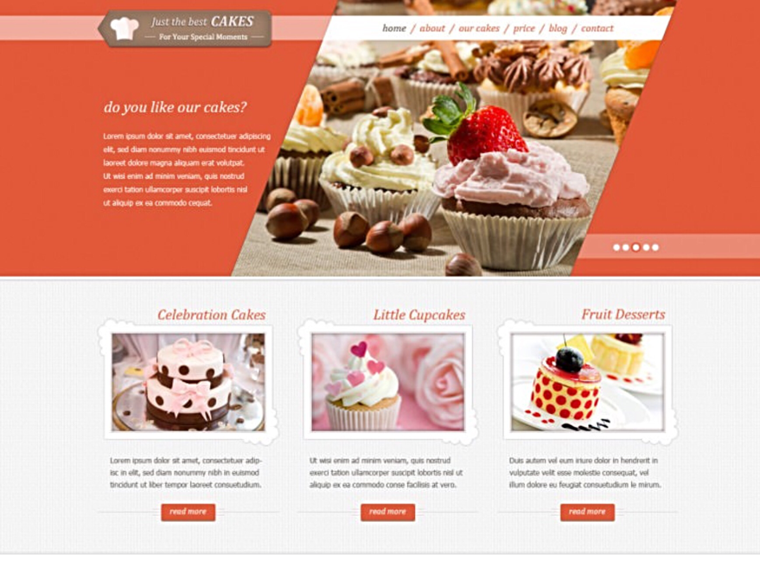Cupcake Bakery

By Brigett Hurley

Angular website

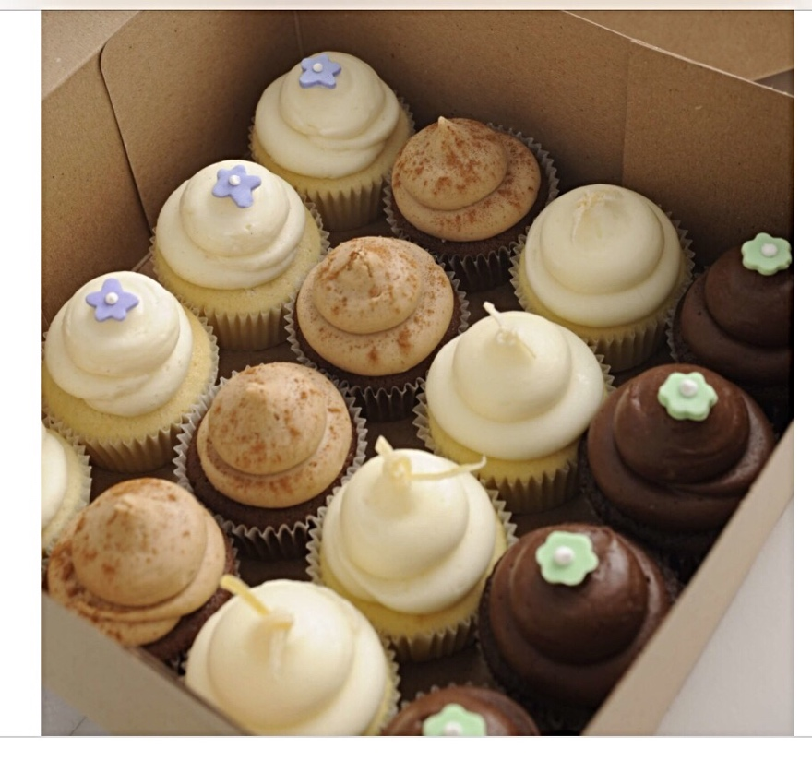

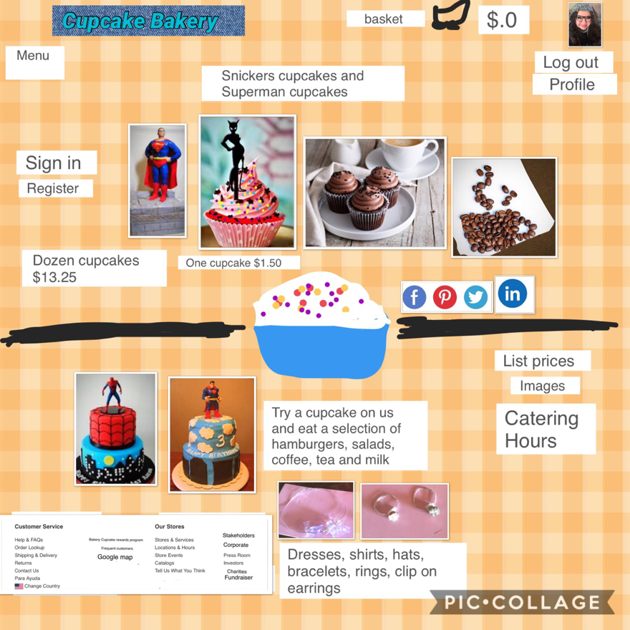

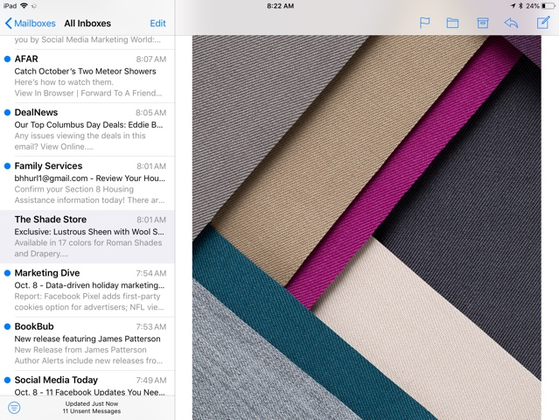Shades for BACKGROUND

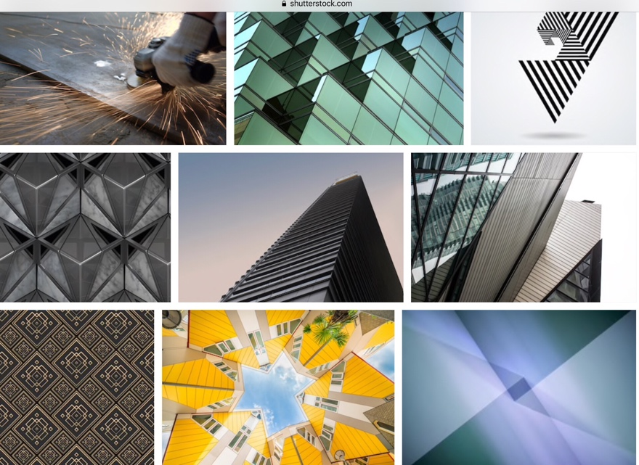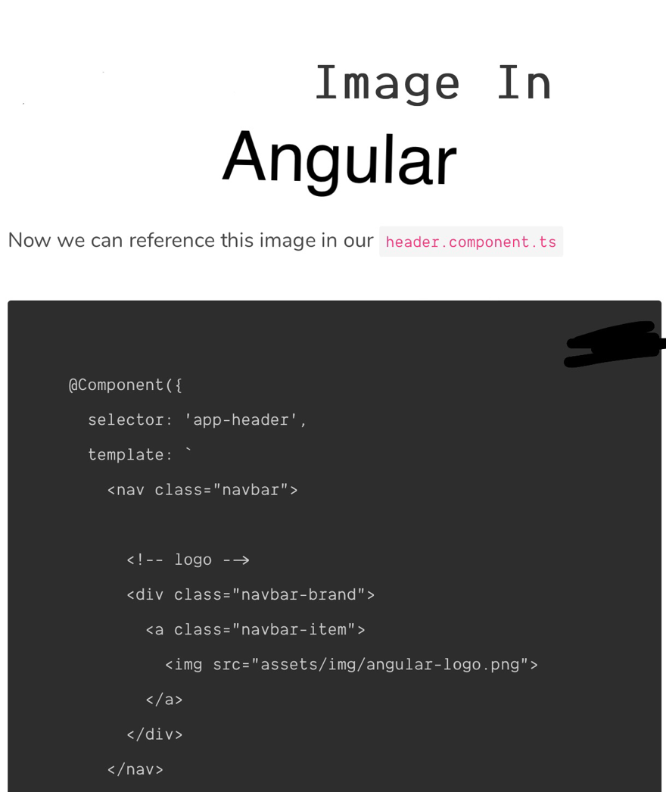

# Project Angular PHP

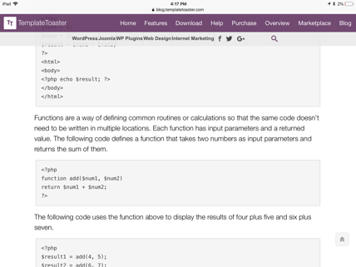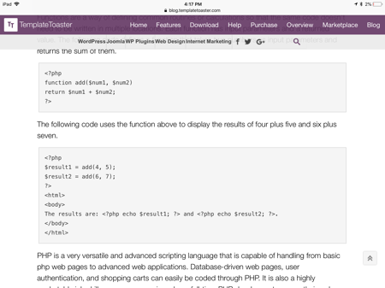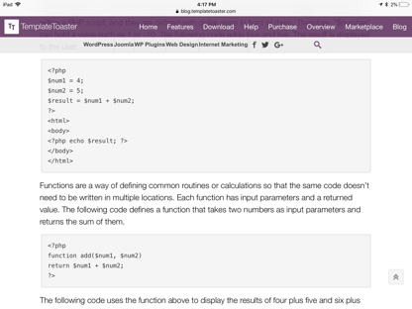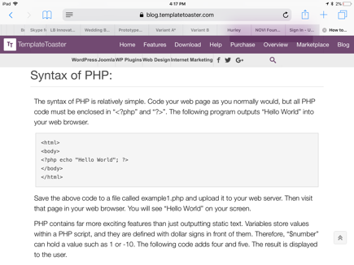

This is is a project to make, bake and sell affordable cupcakes by one or a dozen, yet quality, design and

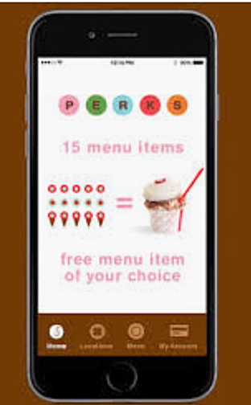

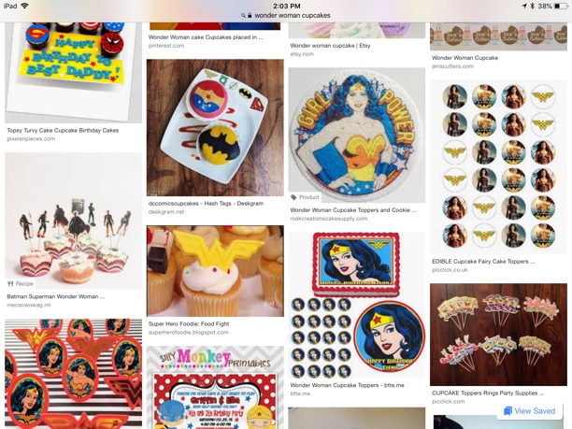 ingredients are customer wishes on any day. This is Cupcake Bakery. <head><title><subtitle>separated by paragraphs to left side of page. <text> a web application, Google search website “Cupcake Bakery” business offering catering, location, delivery, pickup, takeout, charities, fundraising, home page 14 pages long, mobile, app for App Store IOS, iPhone, iPad, and laptop. Flour, powder sugar, frosting, fondue, rice crispy, icing, sprinkles and candy such as, snickers, peanut butter cups, chocolate, tweenkies, Hershey’s and superheroes such as, Superman, Wonder Woman, Batman, and Spider-Man. Commerce and Shopify to sell with other items such as, bracelets, rings and necklaces and clip earrings, dresses, shirts and caps. Description of cupcakes with number as in 1. Snickers cupcake buttercream filling, white frosting, sprinkles and mini bite size snickers on top $1.50 quantity click on snickers cupcake image to order. Add in quantity.

Description, price, quantity, number balance due, credit card, PayPal, debit card balance due with tax.

Ship and deliver

Address

State, Zip code and Country.

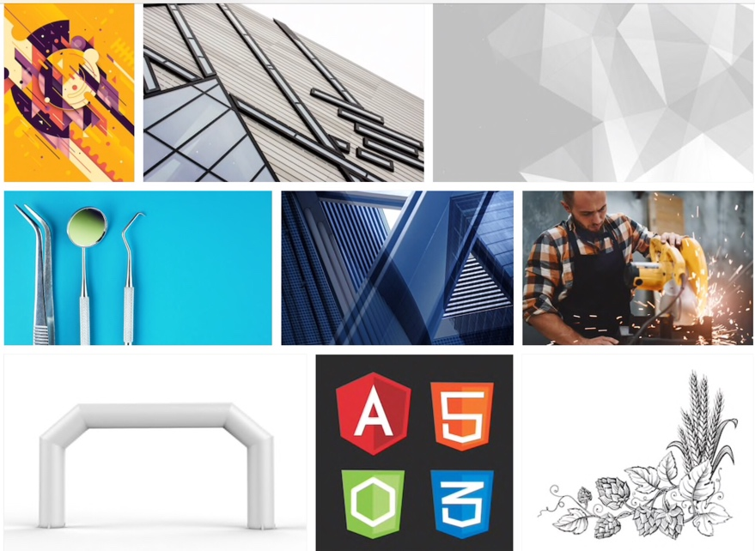

# Cupcake Bakery

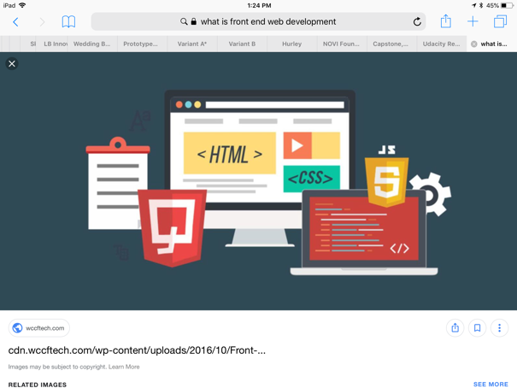

The prices, each cupcake $1.50 for a dozen $13.25 customer receives coffee, tea, milk, Pepsi, and in hot and cold drinks with cream milk and sugar, stirs, and packets. Also, hamburger, couscous chicken garbanzo salad with lettuce and spinach and dressings of three kinds. Hamburger is cheese, lettuce, bacon, tomatoes, pickles, condiments, chili, in layers. Onion on side. Tortilla chips. Fabrics patterns cut out and sew, buy quantity in hats and design craft Hobby Lobby or Joanne’s and Michaels. It is clothing with cupcake bakery.

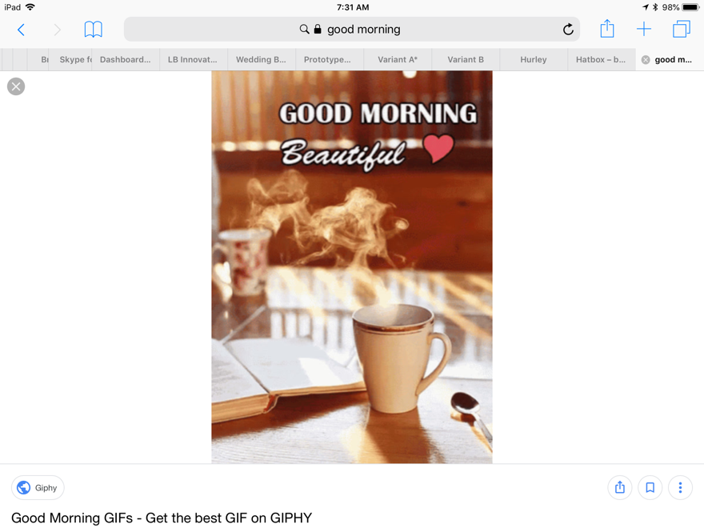

Bakery cupcake images

My cupcake journal in scroll left side with menu. My wish list.

Common file in Angular http:// console game Nintendo

Google play, AppStore and retail stores.

Scroll bar left side Holidays Specials

Christmas Santa Clause, candy cane Christmas tree

Sell Christmas stockings

Easter easter bunny, Easter egg, hallow chocolate, cream filled yellow cram eggs

Sell Easter baskets.

Halloween acorn candy, pumpkin orange cupcake

Ghost cupcake made of fandu and rice crispy

Valentine’s Day valentine heart candy sayings hard candy sugar candy, pink, white, and red.

Solid dove chocolate and rose cupcake

Mother’s Day, pink and white cupcakes with greeting card

Father’s Day tools cupcake with greeting card

Occasions

Weddings

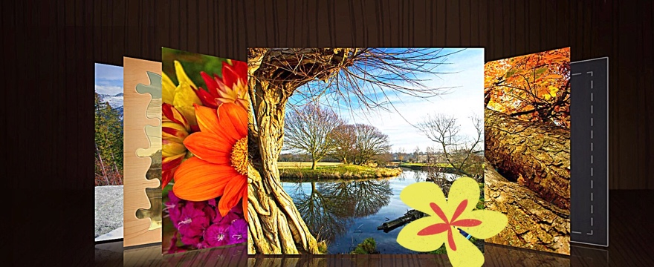

Birthdays

Anniversaries

Custom cupcakes

<h1> Cupcake Bakery</h1> input type app component

Pick a charity to give 25% off a dozen

Fundraiser for a cause 2 dozen cupcakes

Thanksgiving

KitKat fall chocolate sprinkles cupcakes

Sprinkles on everything

Kisses cupcakes

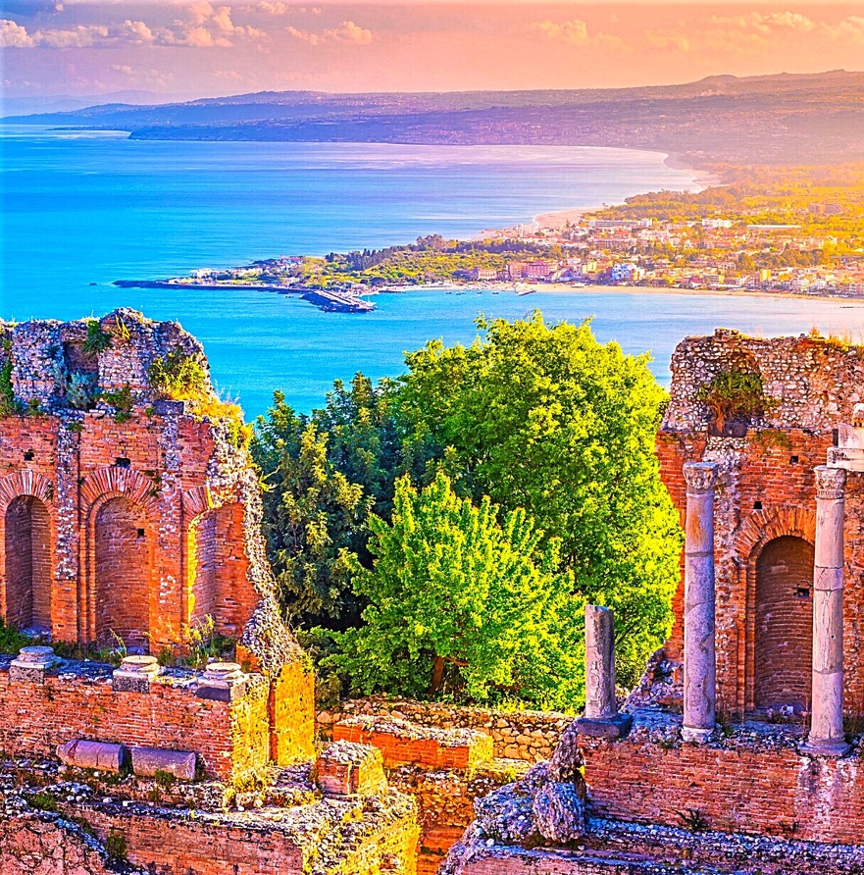

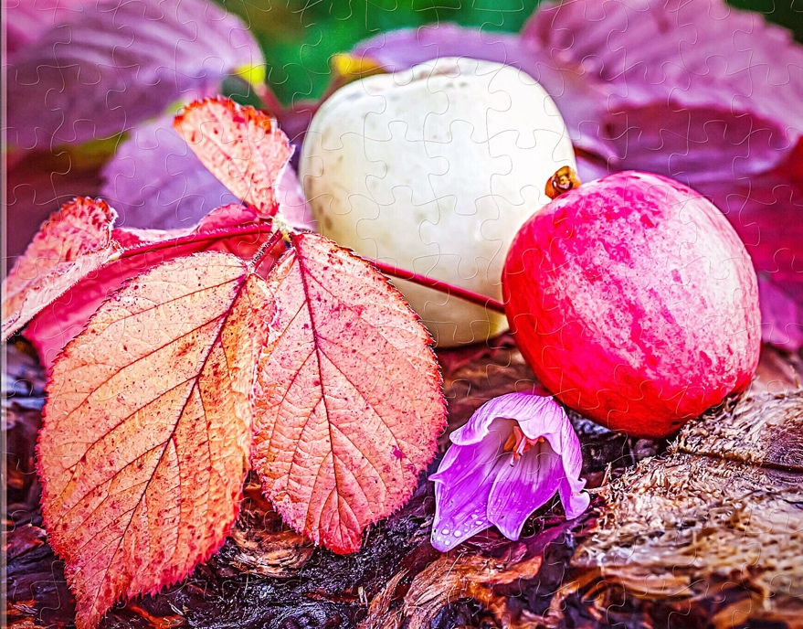

This could be a real startup business corporate another Starbucks. A definitely dream come true for customers wanting sweets that are quality, gourmet, and affordable. A great packaged cupcake for the whole year. Custom cupcakes too. Cupcake Bakery in a neighborhood of homes, parks, church, grocery stores, building, gas station, fire trucks, police stations wanting cupcakes. We can also, carry donuts, hamburgers, salads, coffee, tea and milk. We will have clothes, jewelry and hats for those customers wanting more.

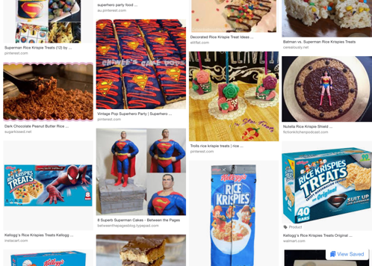

# Candy cupcakes childhood

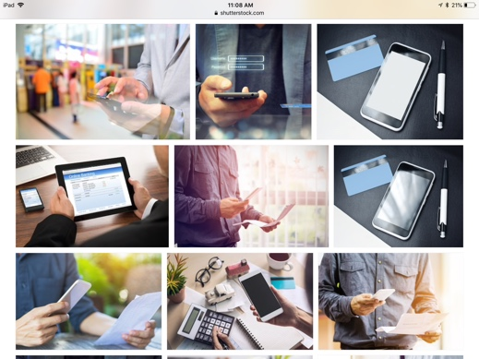

Plain cupcake then insert a butter cream then cover with a frosting top then add snickers, or add peanut butter cup, mini bite size, tweenkies, Hershey’s and sprinkles.

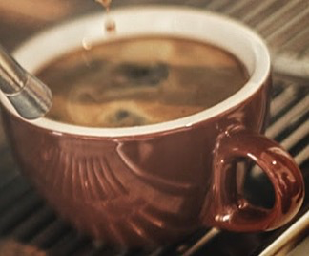

# Superheroes from childhood cupcakes

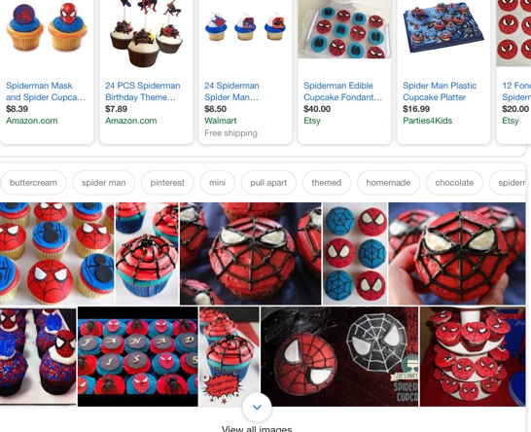

Plain cupcake insert butter cream top frosting add Spider-Man, Wonder Woman, Superman, Cat Woman and add to top frosting made of rice crispy and fondue, color, chocolate strings with cotton candy spray paint food.

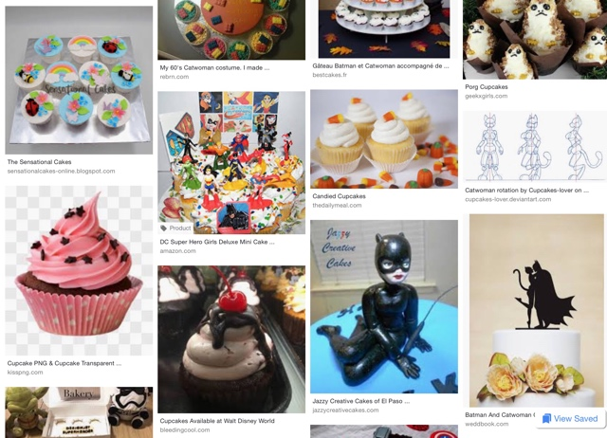Brigida Brigett Hurley, [bhhurl1@gmail.com](mailto:bhhurl1@gmail.com), 480-400-2734, startup cupcake bakery in community of homes, church, shopping, neighborhood. Online shopping, website, advertising on Facebook, AdWords, Google analytics. Sponsors.

This is a cupcake bakery project with angular file, with application, mobile, application.

